**Figure 1.** Map of the locations where temperature data were collected and indicating which locations were used for validation or model calibration (fitting). Many locations were used for both with some years withheld for validation. No individual datum was used for both calibration and validation.



**Figure 2.** Hierarchical structure of the daily stream temperature model. The observed daily temperatures are $t\_{h,r,y,d}$ at HUC8 $h$ and reach $r$ in year $y$ on day $d$. In general, $\mu$ represent means, $\sigma$ represent standard deviations, $B$ represent vectors of coefficients with subscripts represnting the level of variation, $\Sigma$ is the covariance matrix, $\rho$ is the correlation matrix, $\omega$ is the expected temperature as a function of the deterministic components prior to inclusion of temporal autocorrelation, and $\delta$ is the autocorrelation coefficient. See details in the text for further description of the coefficients.](Figures/Hierarchical\_Structure.pdf)

/Users/djhocking/Documents/Research/Stream_Climate_Change/conteStreamTemperature_northeast/manuscripts/Figures/Hierarchical_Structure.pdf

**Figure 3.** Relationship between observed and predicted water temperature for the validation data withheld from modeling fitting.

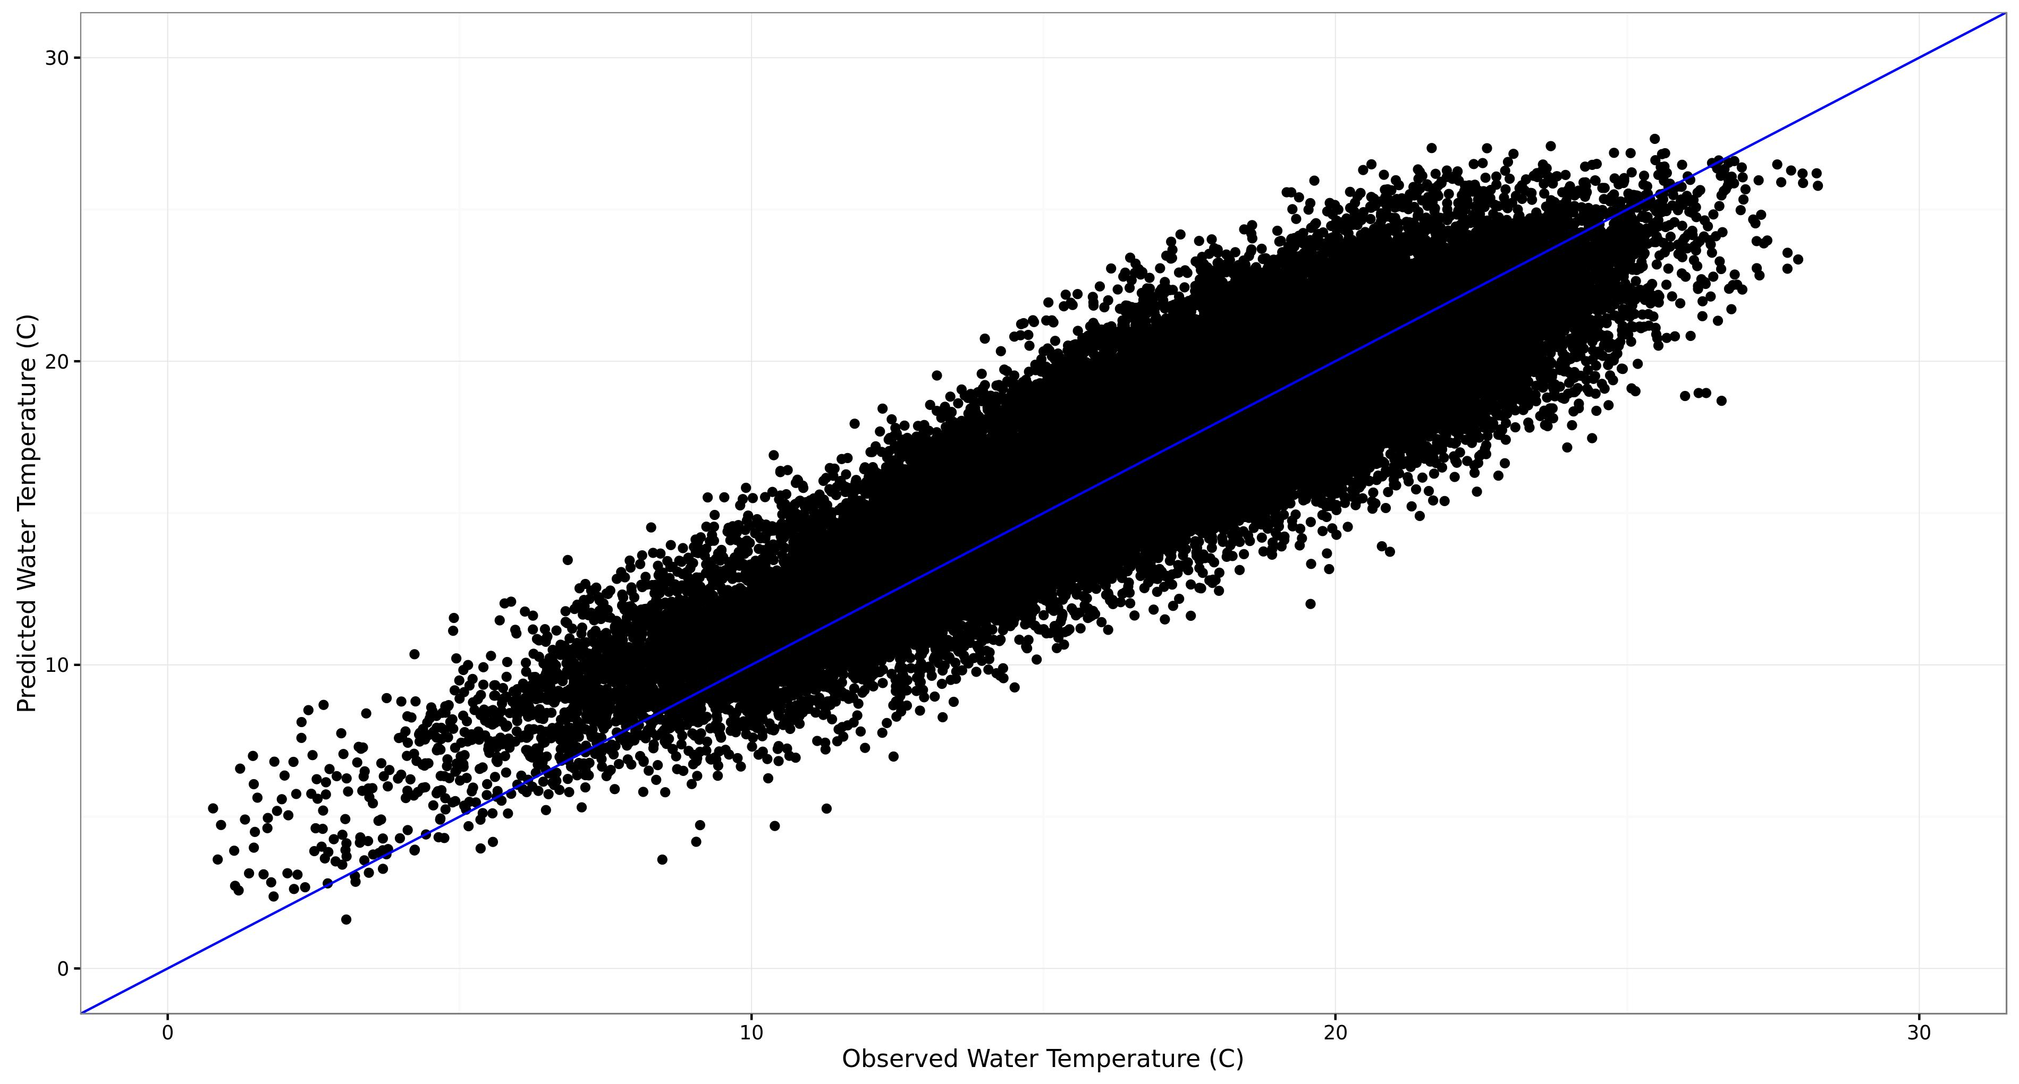

**Figure 4.** Map of the mean annual maximum 30-day mean stream temperature (mean temperature during the warmest 30-day period each year). The inset shows how much local variation there is that is not clearly visible on the regional map. Gray areas have no predictions, usually because they are in larger streams, outside the bounds of the data used in the model (>200 $km^2$ drainage area). Results are presented as catchments delineated based on the stream reaches because at this scale stream lines would blend together and not provide a smooth visual map surface - \*not sure if I need to include this, maybe wait to see if reviewers say anything\*

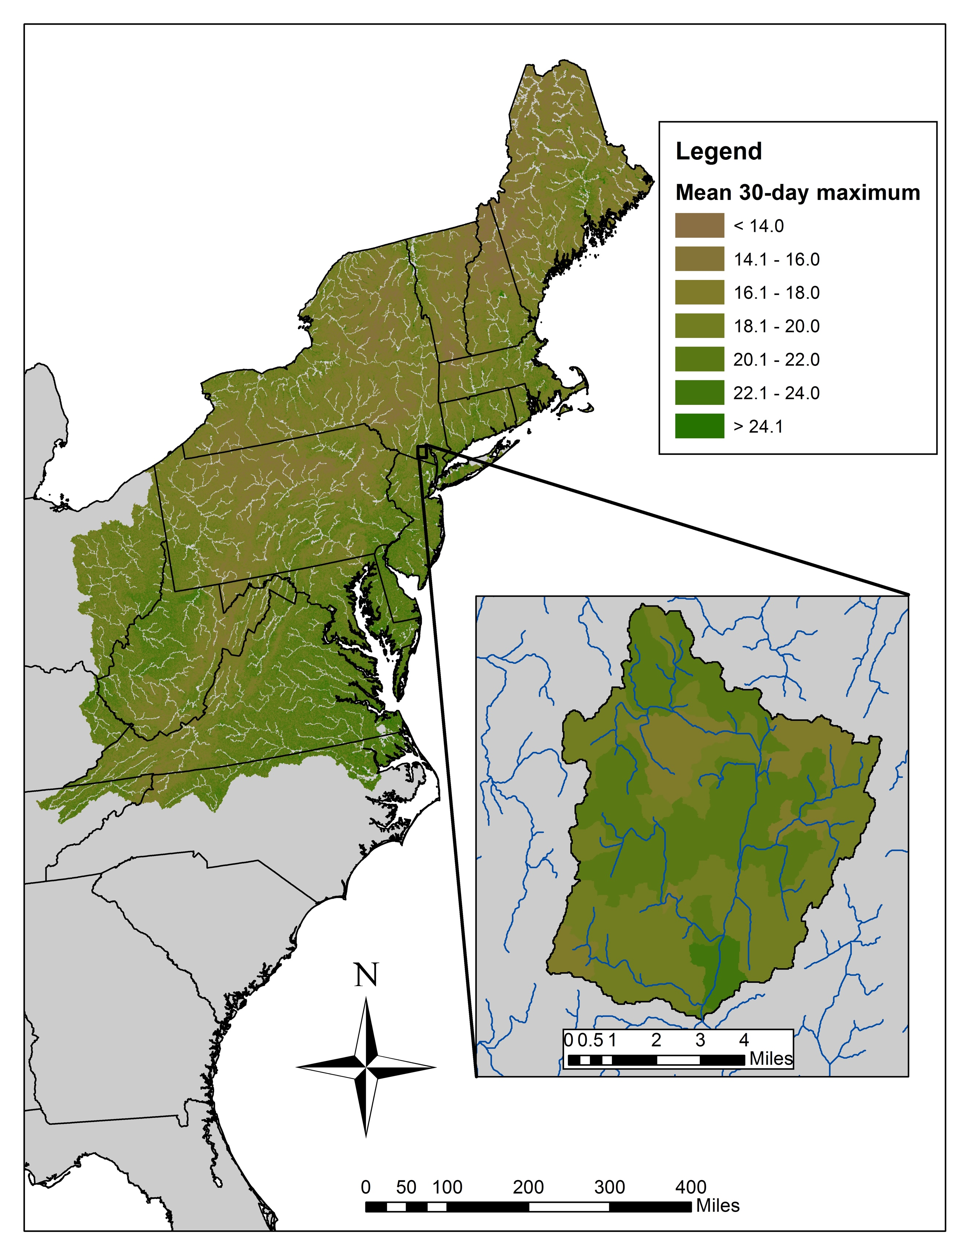

**Figure 5.** Histograms of the distribution of values for various derived metrics across all stream reaches.

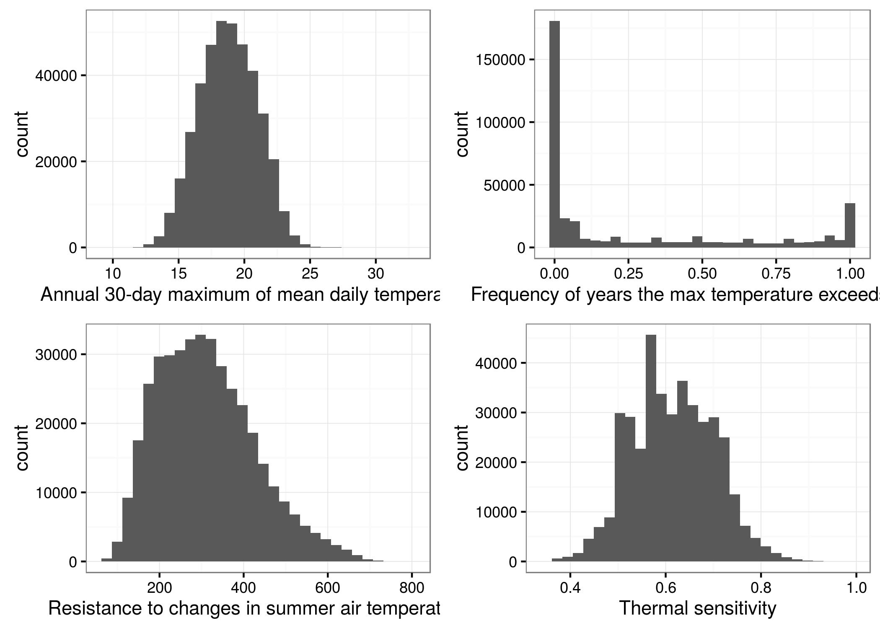

Supplements if necessary

![text with $\sigma=2$ equation](Figures/rmse\_2010\_obs\_plot.jpg)

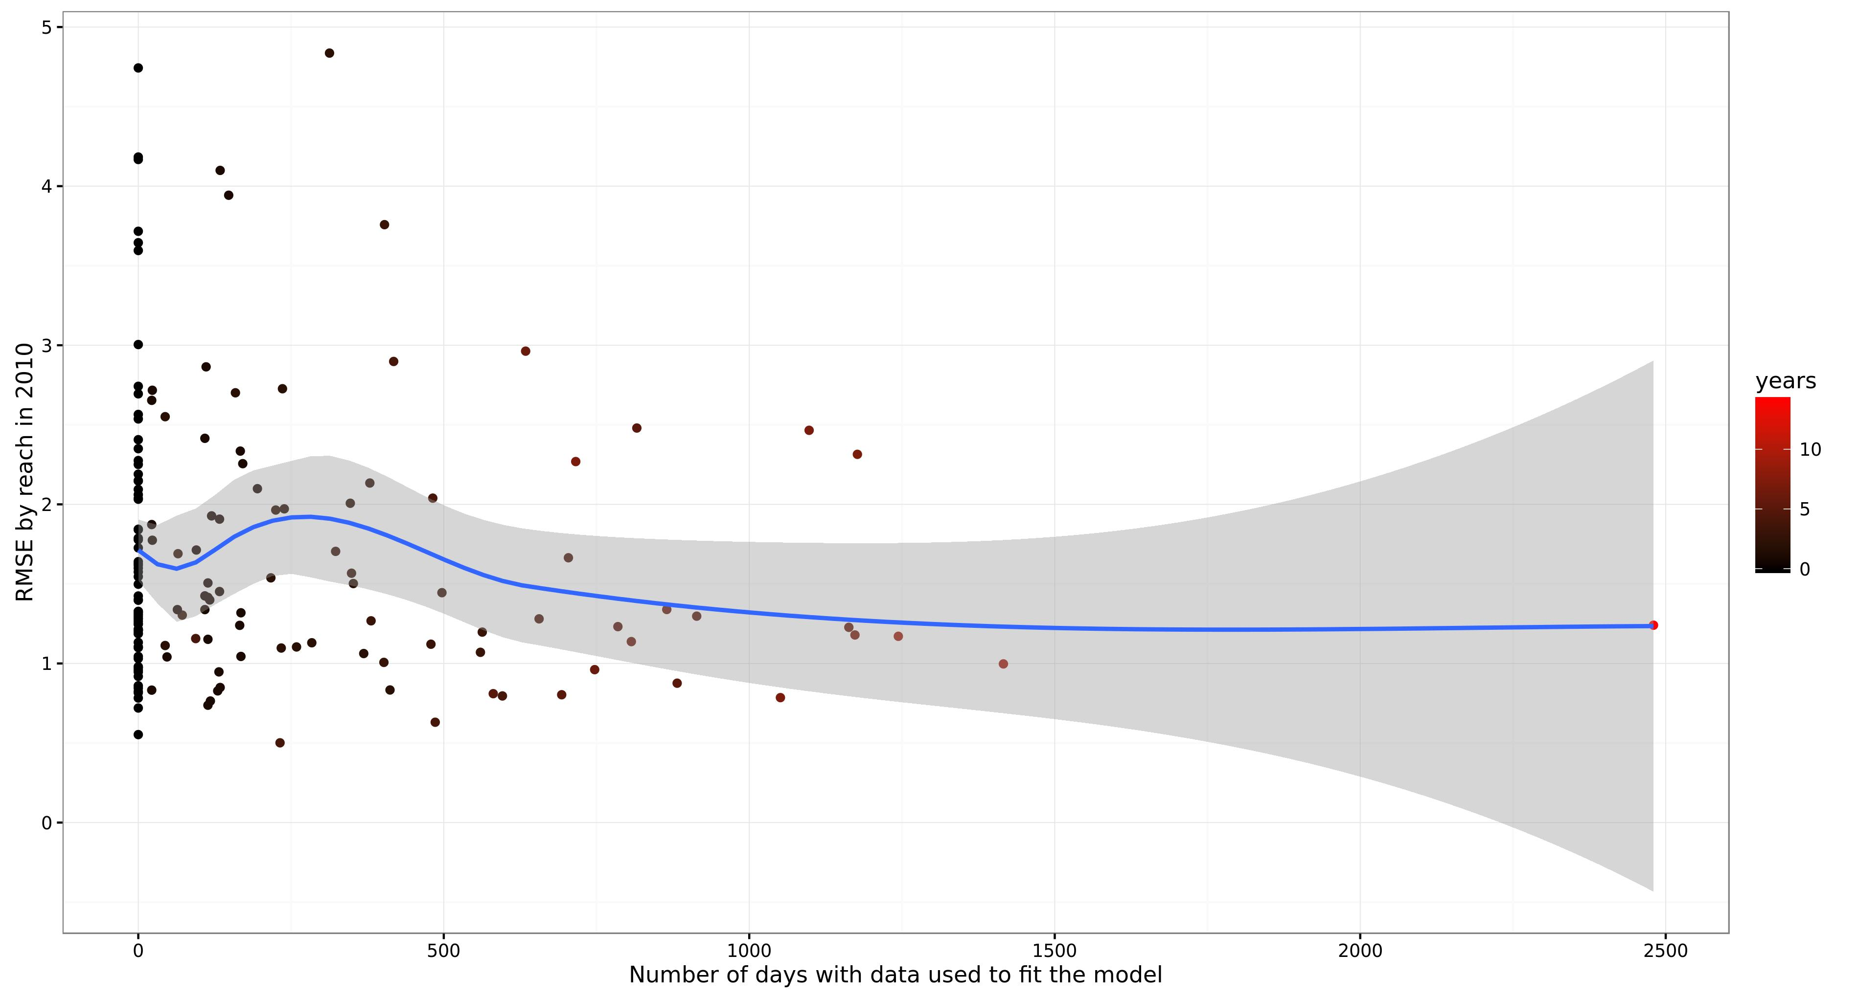

![](Figures/rmse\_2010\_valid\_obs\_plot.jpg)



**Tables**

**Table 1.** Summary of data used to model daily stream temperature. The number of records represents the number of raw temperature measurements (sub-daily) and locations used to create the daily water temperature timeseries for *Nyears* at 2,413 stream reaches (catchments).

| **State** | ***Nrecords*** | ***Nyears*** | ***Nlocations*** | ***Nreaches*** |
| --- | --- | --- | --- | --- |
| CT | 5,007,479 | 19 | 515 | 418 |
| DE | 294,591 | 10 | 1 | 1 |
| MA | 3,212,204 | 20 | 628 | 546 |
| MD | 258,076 | 13 | 497 | 402 |
| ME | 5,522,845 | 22 | 274 | 189 |
| NH | 17,191,459 | 9 | 151 | 124 |
| NJ | 247,974 | 4 | 61 | 42 |
| NY | 6,357,709 | 20 | 292 | 266 |
| PA | 17,280,353 | 10 | 162 | 142 |
| RI | 2,615 | 3 | 4 | 4 |
| VA | 159,334 | 2 | 41 | 41 |
| VT | 21,161 | 13 | 54 | 53 |
| WV | 835,882 | 8 | 214 | 185 |
| Totals: | 56,391,682 | 22 | 2894 | 2413 |

**Table 1.** Description and original source of variables used in the model.

| **Variable** | **Description** | **Source** |
| --- | --- | --- |
| Total Drainage Area | The total contributing drainage area from the entire upstream network | [The SHEDS Data project](http://conte-ecology.github.io/shedsData/) |
| Riparian Forest Cover | The percentage of the upstream 61 m (200 ft) riparian buffer area that is covered by trees taller than 5 meters | [The National LandCover Database (NLCD)](http://www.mrlc.gov/nlcd06_data.php) |
| Daily Precipition | The daily precipitation record for the individual local catchment | [Daymet Daily Surface Weather and Climatological Summaries](https://daymet.ornl.gov/) |
| Daily Air Temperature | The daily mean air temperature record for the individual local catchment as the mean of the minimum and maximum daily temperature from Daymet | [Daymet Daily Surface Weather and Climatological Summaries](https://daymet.ornl.gov/) |
| Upstream Impounded Area | The total area in the contributing drainage basin that is covered by wetlands, lakes, or ponds that intersect the stream network | [U.S. Fish & Wildlife Service (FWS) National Wetlands Inventory](http://www.fws.gov/wetlands/Data/Data-Download.html) |
| Percent Agriculture | The percentage of the contributing drainage area that is covered by agricultural land (e.g. cultivated crops, orchards, and pasture) including fallow land. | [The National LandCover Database](http://www.mrlc.gov/nlcd06_data.php) |
| Percent High-Intensity Development | The percentage of the contributing drainage area covered by places where people work or live in high numbers (typically defined as areas covered by more than 80% impervious surface) | [The National LandCover Database](http://www.mrlc.gov/nlcd06_data.php) |

**Table 2.** Regression summary table with coefficient estimates including the mean, standard deviation (SD), and 95% credible intervals (LCRI = 2.5%, UCRI = 97.5%).

**Fixed effects:**

| **Parameter** | **Mean** | **SD** | **LCRI** | **UCRI** |
| --- | --- | --- | --- | --- |
| Intercept | 16.69 | 0.135 | 16.4182 | 16.949 |
| AirT | 1.91 | 0.022 | 1.8620 | 1.950 |
| 7-day AirT | 1.36 | 0.029 | 1.3015 | 1.417 |
| 2-day Precip | 0.06 | 0.002 | 0.0546 | 0.063 |
| 30-day Precip | 0.01 | 0.006 | 0.0005 | 0.026 |
| Drainage Area | 0.04 | 0.096 | -0.1452 | 0.232 |
| Impounded Area | 0.50 | 0.095 | 0.3181 | 0.691 |
| Forest Cover | -0.15 | 0.047 | -0.2455 | -0.059 |
| AirT x 2-day Precip | 0.02 | 0.002 | 0.0195 | 0.028 |
| AirT x 30-day Precip | -0.01 | 0.004 | -0.0224 | -0.007 |
| AirT x Drainage | -0.06 | 0.029 | -0.1170 | -0.006 |
| AirT x Impounded Area | 0.02 | 0.029 | -0.0345 | 0.077 |
| AirT x Forest | -0.02 | 0.015 | -0.0508 | 0.009 |
| 2-day Precip x Drainage | -0.04 | 0.002 | -0.0424 | -0.034 |
| 30-day Precip x Drainage | -0.06 | 0.006 | -0.0709 | -0.046 |
| AirT x 2-day Precip x Drainage | -0.01 | 0.002 | -0.0156 | -0.008 |
| AirT x 30-day Precip x Drainage | -0.01 | 0.004 | -0.0193 | -0.004 |
| AR1 | 0.77 | 0.002 | 0.7681 | 0.776 |

**Random effects:**

| **Group** | **Coef** | **SD** | **Variance** |
| --- | --- | --- | --- |
| Site | Intercept | 1.03 | 1.060 |
|  | AirT | 0.29 | 0.083 |
|  | 7-day AirT | 0.35 | 0.120 |
| HUC8 | Intercept | 0.59 | 0.345 |
|  | AirT | 0.27 | 0.072 |
|  | 7-day AirT | 0.26 | 0.066 |
| Year | Intercept | 0.28 | 0.076 |

**HUC8 coefficient correlations:**

|  | **Intercept** | **AirT** | **7-day AirT** |
| --- | --- | --- | --- |
| Intercept |  |  |  |
| AirT | 0.64 |  |  |
| 7-day AirT | 0.338 | 0.234 |  |

**Table 3.** The root-mean-squared error (RMSE) based on the data used and excluded from different subsets of the validation data. N is the number of daily temperature observations used in each subset of the data. Validation data was completely withheld at random from the data used in model fitting (calibration).

| **Data Used** | **RMSE** | **N** |
| --- | --- | --- |
| Fitted RMSE | 0.59 | 248517 |
| Overall validation RMSE | 2.03 | 100909 |
| Missing reach-year but reach, HUC8, and year with data | 1.90 | 18401 |
| Missing reaches but HUC8 and year with data | 1.96 | 42602 |
| Missing HUC8 but year with data | 2.52 | 1081 |
| Missing year but reaches and HUC8 with data | 2.06 | 19090 |
| 2010 excluded but all other data available | 2.13 | 38825 |
| No data for reach, HUC8, or year | 1.83 | 2644 |

**Table 4.** Summary and description of derived metrics for each stream reach summarized for predictions from 1980-2015. The mean number of days over 18 and 22 C were only calculated for predictions in the middle 194 days of the year to avoid problems outside the synchronized period of the year while keeping the length consistent among reaches across the region.

| **Metric** | **Mean** | **Min** | **Max** | **Description** |
| --- | --- | --- | --- | --- |
| Mean maximum temperature | 20.57 | 12.61 | 34.11 | Maximum daily mean water temperature (C) averaged over 36 years (1980 - 2015) |
| Max maximum temperature | 22.30 | 14.05 | 35.25 | Maximum over years of the maximum daily mean temperature |
| Mean July temperature | 18.25 | 8.83 | 32.34 | Mean daily July temperature over years |
| Mean August temperature | 17.74 | 8.52 | 31.76 | Mean daily August temperature over years |
| Mean summer temperature | 17.49 | 7.92 | 31.77 | Mean daily summer temperature over years |
| Mean 30-day maximum temperature | 18.76 | 9.68 | 32.71 | Maximum 30-day temperature for each year averaged over years |
| Mean number of days over 18 C | 47.73 | 0.00 | 194.00 | Mean number of days per year the mean daily temperature exceeds 18 C |
| Mean number of days over 22 C | 5.17 | 0.00 | 194.00 | Mean number of days per year the mean daily temperature exceeds 22 C |
| Annual frequency of exceeding 18 C | 0.86 | 0.00 | 1.00 | Frequency of years the mean daily temperature ever exceeds 18 C |
| Annual frequency of exceeding 22 C | 0.28 | 0.00 | 1.00 | Frequency of years the mean daily temperature ever exceeds 22 C |
| Mean annual resistance | 311.95 | 69.96 | 789.80 | Mean annual resistance of water temperature to peak (summer) air temperature |
| Thermal sensitivity | 0.61 | 0.35 | 0.98 | Thermal sensitivity of water temperature to changes in air temperature |